

**Radio Tomographic Imaging**

**Data Collection Stage (Stage 1)**

**Yan Bingtao**

**Advisor: Dr. Ram Sundaram**

**May 2015**

**Abstract**

Radio Tomographic Imaging (RTI) is an emerging technology to image objects in wireless sensor network by analyzing the attenuation of the received signal strength (RSS). There are two stage in this project, which are Data Collection Stage (stage 1) and Information Display Stage (stage 2).

In this report, only Data Collection Stage (stage 1) will be presented. TelosB Motes are the main devices used in this project. They act as sensors and base station. All the sensors will be transmitters and receivers. After they collect data from each other, they will send to base-station mote. Base-station mote will collect the data and sent to the RTI interface to do further analyzing and rearranging. In the end, they will give an output table to indicate RSS, and pass them to Information Display Stage (stage 2) to do object imaging.

So far, the wireless sensor network was tested in different size, such as 2*2, 3*3, 4*4 and 12*12. In most cases the objectives of the project were met. However, recommendations for future work are outlined in this report. The future work can be separated to increase the reliability, further reduce package loss and test in outside environment.

**Acknowledgements**

I would like to express appreciation to my thesis mentor, Dr.Ram Sundaram, for his dedication and commitment in helping me complete Radio Tomographic Imaging (Stage 1—Data Collection). Thank you for providing so many creative insights for Tomographic Imaging System and give me a clear instruction. Special thanks as well to Liaw, Soon Aun and Schultz, Brett M for guiding me and doing the troubleshooting part together.

My gratitude goes to ECE lab manager, Jonathan Liaw for providing support and essential tools needed for the project.

**Table of Contents**

Abstract ---------------------------------------------------------------------------------------------------I  
Acknowledgements-------------------------------------------------------------------------------------II  
List of Tables----------------------------------------------------------------------------------------------IV  
Chapter 1. Introduction--------------------------------------------------------------------------------1  
 1.1 Overview----------------------------------------------------------------------------------1  
 1.2 Objectives---------------------------------------------------------------------------------2  
Chapter 2. Process---------------------------------------------------------------------------------------2  
 2.1 Devices-------------------------------------------------------------------------------------2  
 2.2 Skills required----------------------------------------------------------------------------3  
 2.2.1 Programming languages-----------------------------------------------3  
 2.2.1.1 TinyOS (NesC)-------------------------------------------------3  
 2.2.1.2 Java--------------------------------------------------------------3  
 2.2.2 Cygwin terminal---------------------------------------------------------3  
 2.2.2.1 Setting up Cygwin in Windows 7--------------------------4  
 2.3 Programming-----------------------------------------------------------------------------4  
 2.4 Troubleshooting-------------------------------------------------------------------------5  
 2.4.1 Timers-------------------------------------------------------------------------5  
 2.4.2 Scheduling--------------------------------------------------------------------6  
 2.5 Testing and result-----------------------------------------------------------------------6  
 2.5.1 Different size of the Wireless Sensor Network----------------------6  
 2.5.1.1 2*2 Wireless Sensor Network-----------------------------8  
 2.5.1.2 3*3 Wireless Sensor Network-----------------------------9  
 2.5.1.3 4*4 Wireless Sensor Network-----------------------------9  
 2.5.1.4 12*12 Wireless Sensor Network-------------------------10  
 2.5.2 Working Concept for the Wireless Sensor Network----------------11  
 2.5.3 Reading the Result----------------------------------------------------------12  
 2.5.4 Detailed process for setting up Wireless Sensor Network--------13  
 2.5.4.1 Labeling each TelosB Motes--------------------------------13  
 2.5.4.2 Changing variables in program-----------------------------13  
 2.5.4.3 Writing program into Sensor TelosB Motes-------------15  
 2.5.4.4 Writing program into Base Station TelosB Motes-----18  
 2.6 Reliability test------------------------------------------------------------------------22  
 2.6.1 Success rate----------------------------------------------------------------22  
 2.6.2 Possible errors-------------------------------------------------------------22  
 2.6.2.1 Miss the beginning part---------------------------------------22  
 2.6.2.2 Miss one row of data------------------------------------------22  
3.0 Conclusion and future work-----------------------------------------------------------------23  
Reference---------------------------------------------------------------------------------------------------24

**List of Tables**

Figure 1-1 Project Overview-----------------------------------------------------1

Figure 2-1 TelosB Mote-----------------------------------------------------------2

Figure 2-2 Programming Language--------------------------------------------3

Figure 2-3 Cygwin Terminal-----------------------------------------------------3

Figure 2-4 Java Program---------------------------------------------------------5

Figure 2-5 Base Station Mote--------------------------------------------------7

Figure 2-6 Sensor Mote---------------------------------------------------------7

Figure 2-7 Output sample------------------------------------------------------8

Figure 2-8 2*2 Wireless Sensor Network-----------------------------------8

Figure 2-9 3*3 Wireless Sensor Network-----------------------------------9

Figure 2-10 4*4 Wireless Sensor Network---------------------------------10

Figure 2-11 12*12 Wireless Sensor Network------------------------------11

Figure 2-12 Wireless Sensor Network---------------------------------------11

Figure 2-13 Output File----------------------------------------------------------12

Figure 2-14 Labeled TelosB Mote----------------------------------------------13

Figure 2-14 Open spin.h File----------------------------------------------14

Figure 2-15 Change NUM_NODES----------------------------------------15

Figure 2-16 Cygwin 1---------------------------------------------------------15

Figure 2-17 Cygwin 2---------------------------------------------------------16

Figure 2-18 Cygwin 3---------------------------------------------------------16

Figure 2-19 Cygwin 4---------------------------------------------------------17  
Figure 2-20 Cygwin 5---------------------------------------------------------17

Figure 2-21 Cygwin 6---------------------------------------------------------17

Figure 2-22 Cygwin 7---------------------------------------------------------18

Figure 2-23 Cygwin 8---------------------------------------------------------19

Figure 2-24 Cygwin 9---------------------------------------------------------19

Figure 2-25 Cygwin 10--------------------------------------------------------20

Figure 2-26 Cygwin 11--------------------------------------------------------20

Figure 2-27 Cygwin 12--------------------------------------------------------21

Figure 2-28 Cygwin 13--------------------------------------------------------21

Figure 2-29 Cygwin 14--------------------------------------------------------21  
Figure 2-30 Reliability Test 1-------------------------------------------------22  
Figure 2-31 Reliability Test 2-------------------------------------------------23

1. **Introduction**Radio Tomographic Imaging (RTI) is an emerging technology to image objects in wireless sensor network by analyzing the attenuation of the received signal strength (RSS).

RTI can be used in security system, rescue operations, smart building and many other areas.

RTI can be used both in buildings and outside environment. When an object moves into the wireless sensor network, received signal strength (RSS) will reduce. Furthermore, we used Matlab to image the object in Information Display Stage (stage 2) based on the data, which is collected from the wireless sensor network. However, in this report, we will focus on Data Collection Stage (stage 1).

The purpose of Data Collection Stage (stage 1) was to collect data from all the sensors, and rearrange them to table form, so that can pass to Information Display Stage (stage 2) to do object imaging.

* 1. **Overview**This project, Radio Tomographic Imaging (RTI), can be separated to three main parts, which are:  
     Part 1) Setting up wireless Sensor Network;  
      Part 2) Collecting and rearranging data by Mobile RTI interface;  
      Part 3) Analysing the data and imaging by using Matlab or LabView.

**Stage2**

**Stage1**

**Circular**

**Rectangular**

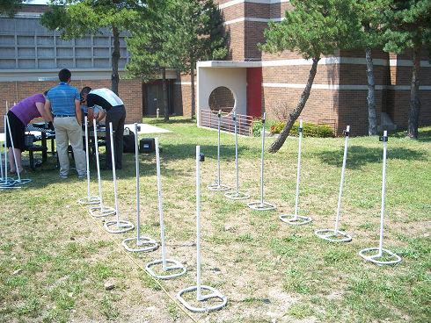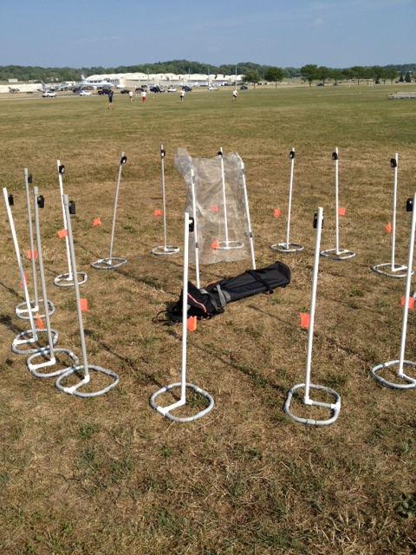

**Wireless Sensor Network**

Mobile RTI Interface

Imaging

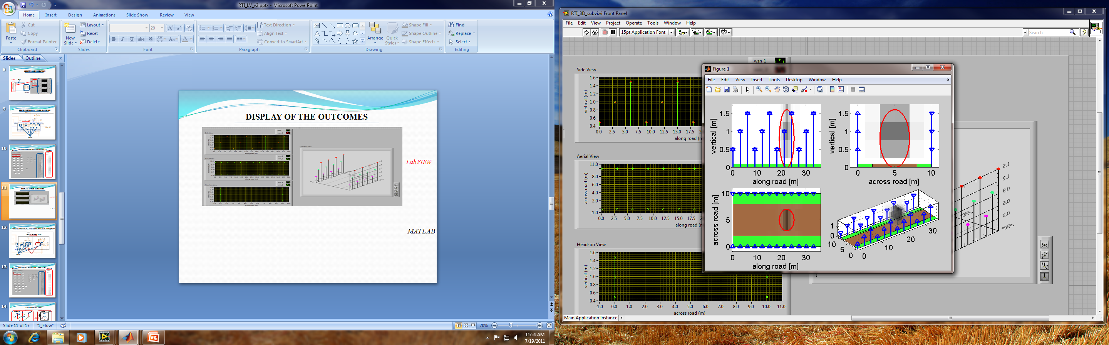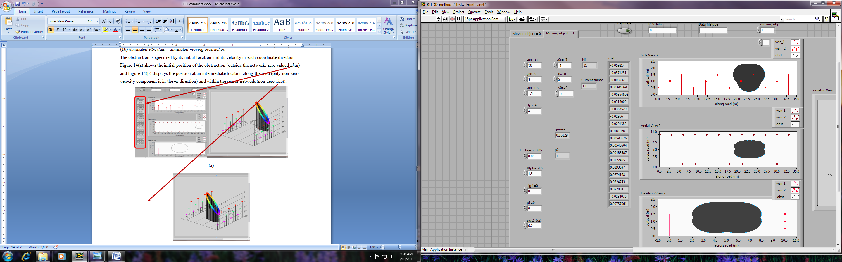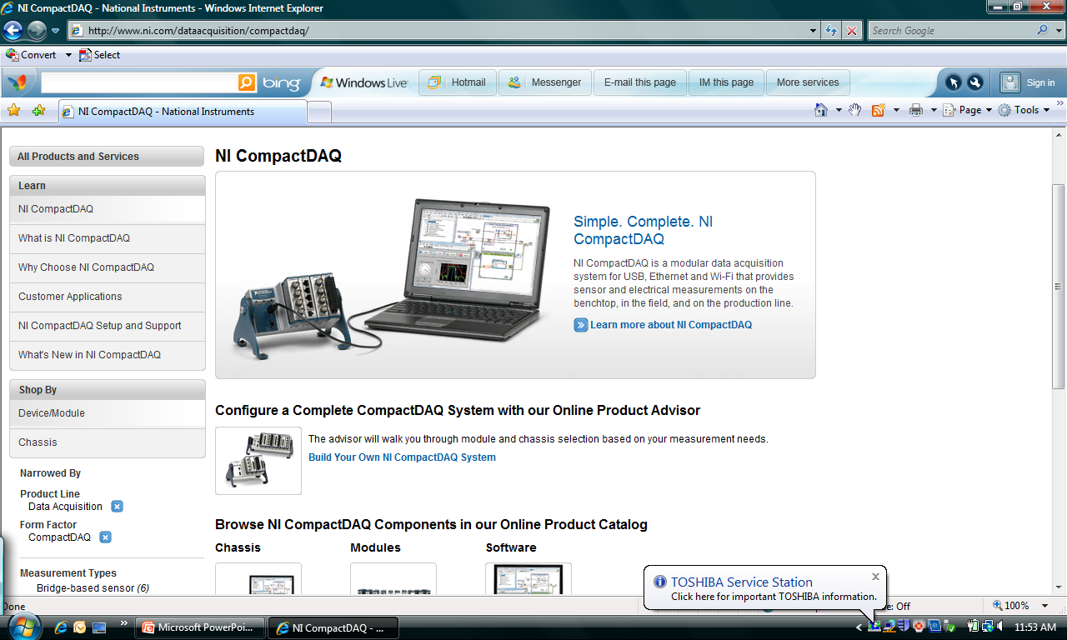

**Figure 1-1 Project Overview**  
  
  
  
However, RTI can be separated to two stages:  
Stage 1) Data Collection Stage;  
 Stage 2) Information Display Stage.

Stage 1 includes Part1 and Part2; Stage 2 includes Part3.  
In this report, we will only focus on Data Collection Stage (stage 1).

* 1. **Objectives**

The objectives of Data Collection Stage (stage 1) were:  
  
 1) Form a Wireless Sensor Network;

2) Program one TelosB Mote as Base Station to collect data;

3) Program other TelosB Motes as transmitters and receivers;

4) Tabulate the data (Signal strength).

1. **Process**
   1. **Devices**The main device used in this project is TelosB Mote. The TelosB Mote bundles all the essentials for lab studies into a single platform including: USB programming capability, an IEEE 802.15.4 radio with integrated antenna, a low-power MCU with extended memory and an optional sensor suite (TPR2420) [1].  
       **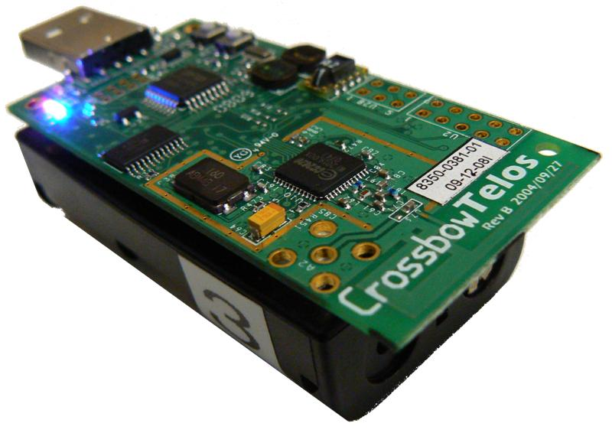  
       Figure 2-1 TelosB Mote**

In this project, TelosB Motes are used as Base Station and Sensor.

* 1. **Skills required**
     1. **Programming languages**The main programming languages used in Data Collection Stage (Stage1) are TinyOS (NesC) and Java.  
        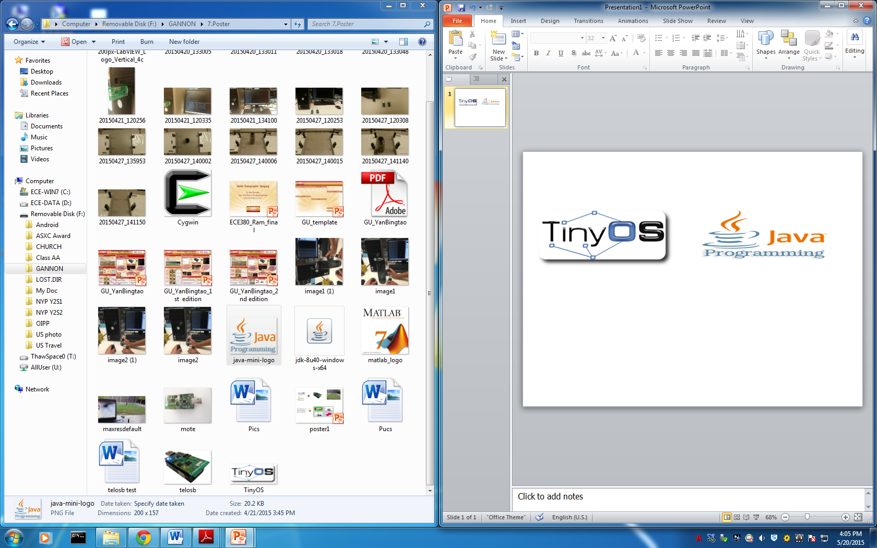  **Figure 2-2 Programming Language**  
        1. **TinyOS (NesC)**TinyOS is an open source, BSD-licensed operating system designed for low-power wireless devices, such as those used in sensor networks, ubiquitous computing, personal area networks, smart buildings, and smart meters.[2]TinyOS (NesC) language is a hardware programming language. For this project, it’s mainly used to control TelosB Motes.
        2. **Java**Java is a programming language and computing platform first released by Sun Microsystems in 1995. [3] Java is mainly used to rearrange data and print output in matrix form, so that Information Display Stage (Stage2) is able to image the object by reading the data.
     2. **Cygwin terminal**

  
 **Figure 2-3 Cygwin Terminal**Cygwin is a large collection of GNU and Open Source tools which provide functionality similar to a Linux distribution on Windows.[4]

By using Cygwin, we are able to write programs into TelosB motes and configure them. Moreover, Cygwin also can collect data from base station mote.

* + - 1. **Setting up Cygwin in Windows 7  
         (For more detailed processes, please refer to**

**Tutorial--Stage1 Part1 & Part2)**

* + - * 1. Set up Java Development Kit(JDK)
        2. Set up Cygwin Manually
        3. Download FTDI Drivers
        4. Install TinyOS Packages
        5. Install and test Java
        6. Reboot the computer, and install a testing program to TelosB Motes

* 1. **Programming**

This part of the program is used to rearrange data (Received Signal Strength) and print them into output file in matrix form, so that Information Display Stage (Stage2) is able to image the object by reading the data. To open and edit the program, “Notepad++” is required.  
  
The following image is the program.

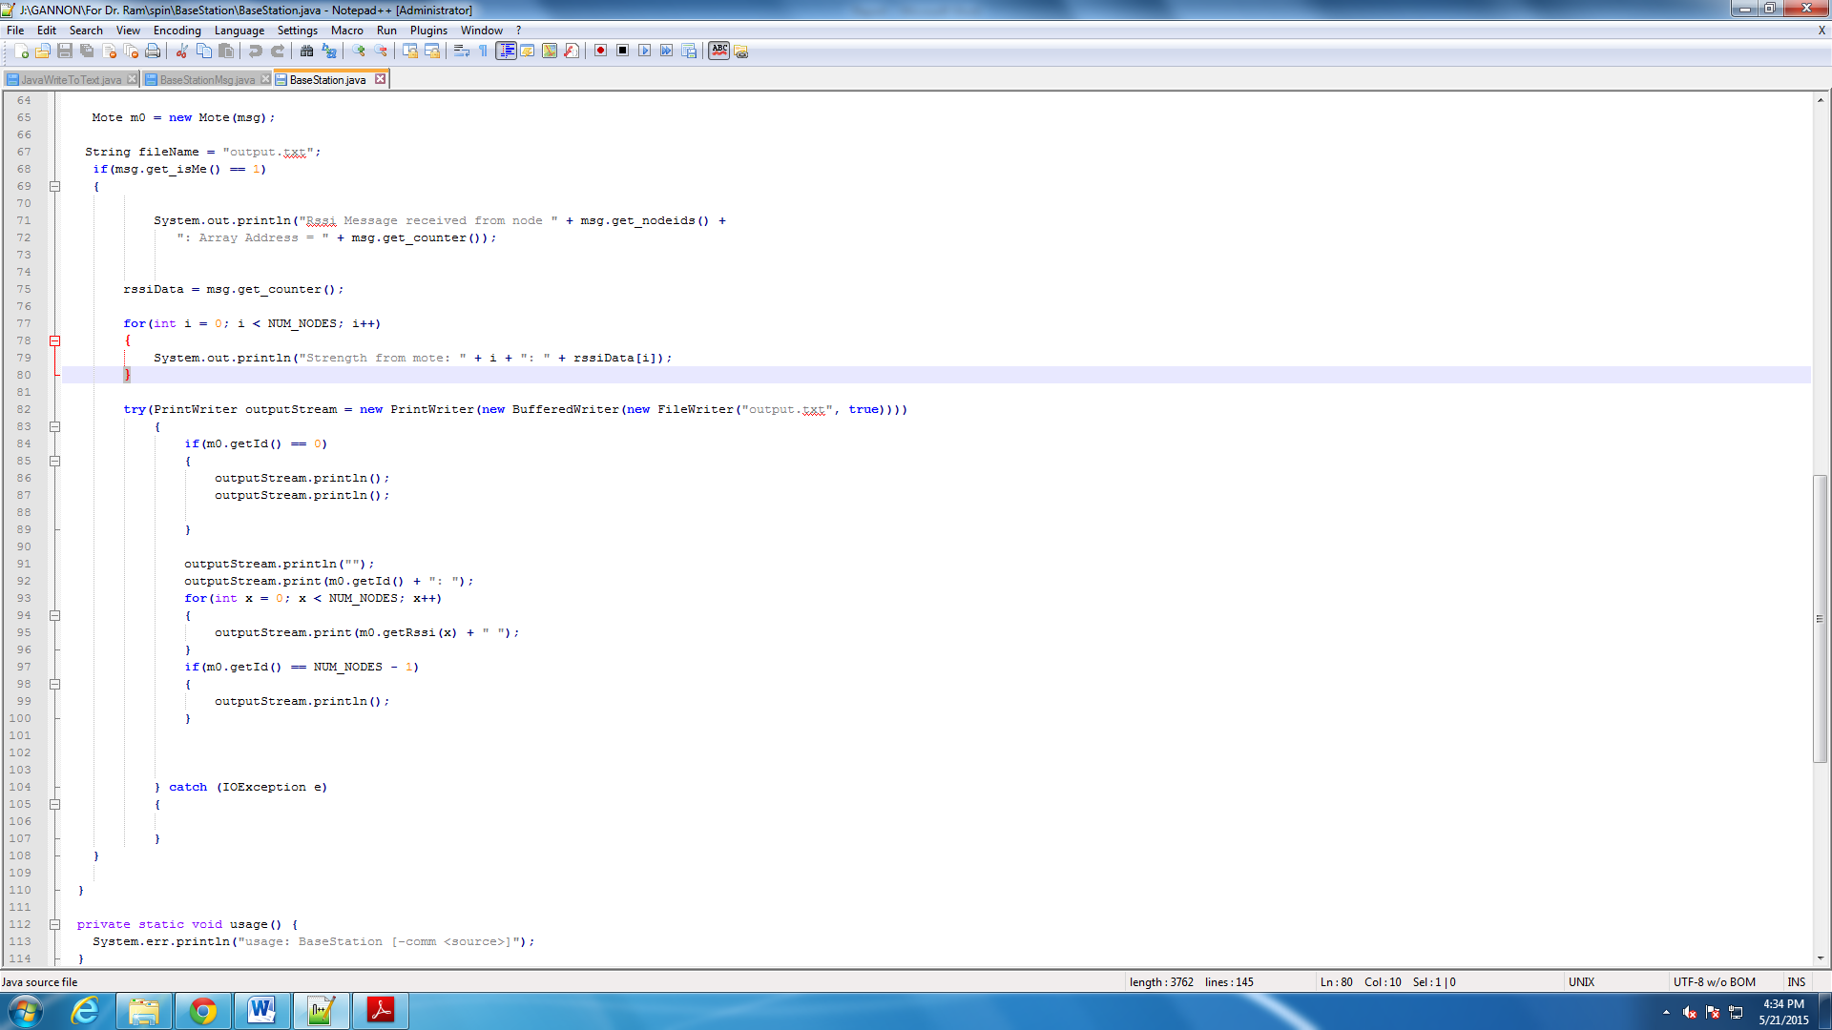

**Figure 2-4 Java Program**

* 1. **Troubleshooting**Data was sent non-incrementally initially, near-impossible to parse into matrix with adjacent data in same-timeframe. In other words, it means the motes did not send the signal in a sequence. Consequently, we were not able to rearrange all the data into matrix form.

There are multiple ways attempted to fix problem

* + 1. **Timers**The first solution in our mind was setting timers to call between the first to last node to send their own data. Offset each other by a minute difference (IE: 20ms).

Successful at start, but errors arose shortly after running system. After around 10 seconds, nodes got desynced and never repaired. Original spin cycle ceased to work properly and could not be called.   
  
Therefore, this solution failed.

* + 1. **Scheduling**This is current implementation. The concept behind is that always increments internal after each motes message has been received.

We also set a time out for all the motes. So if the motes are not responding for 10ms, it will skip this mote and let next mote to send the data.

This method is the most reliable and has extremely low level of data desync.

* 1. **Testing and result**
     1. **Different size of the Wireless Sensor Network**The Wireless Sensor Network can be set in different size. However, in each Wireless Sensor Network, there will be one TelosB Mote acting as Base Station Mote. Other TelosB Motes will be programmed as Sensors. The more the Sensors the user uses, the more accurate the result will be.

There will be only one TelosB Mote programmed as Base Station. Base Station Mote will act as a receiver. It will collect all the data from other Sensor Motes. And pass all the data to Cygwin Terminal.  
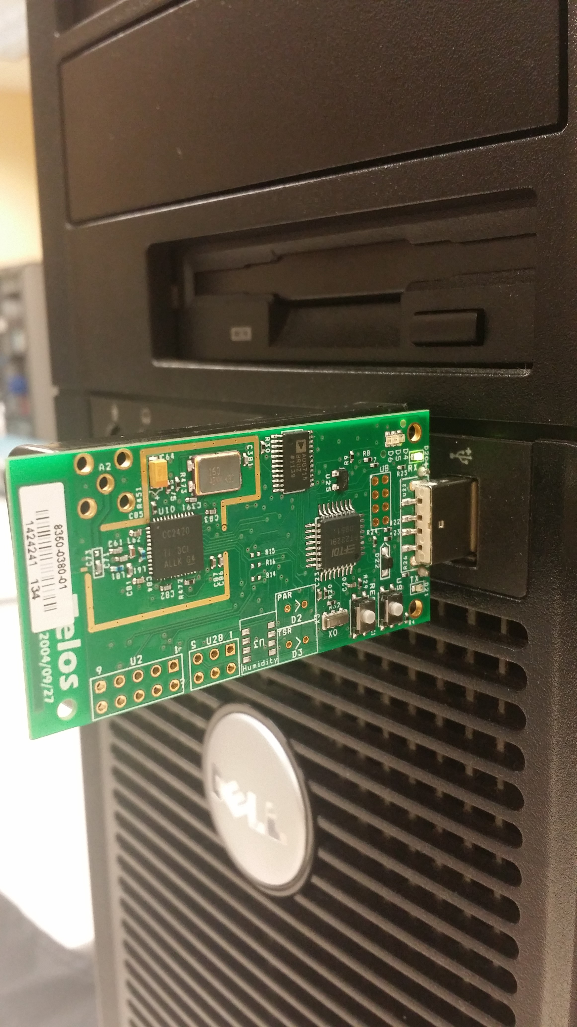  
 **Figure 2-5 Base Station Mote**

The name of the Wireless Sensor Network will depend on the number of sensors used. For example, in the following picture, there 12 TelosB Motes are used in the Wireless Sensor Network. Then we will name this network as 12*12 Wireless Sensor Network.

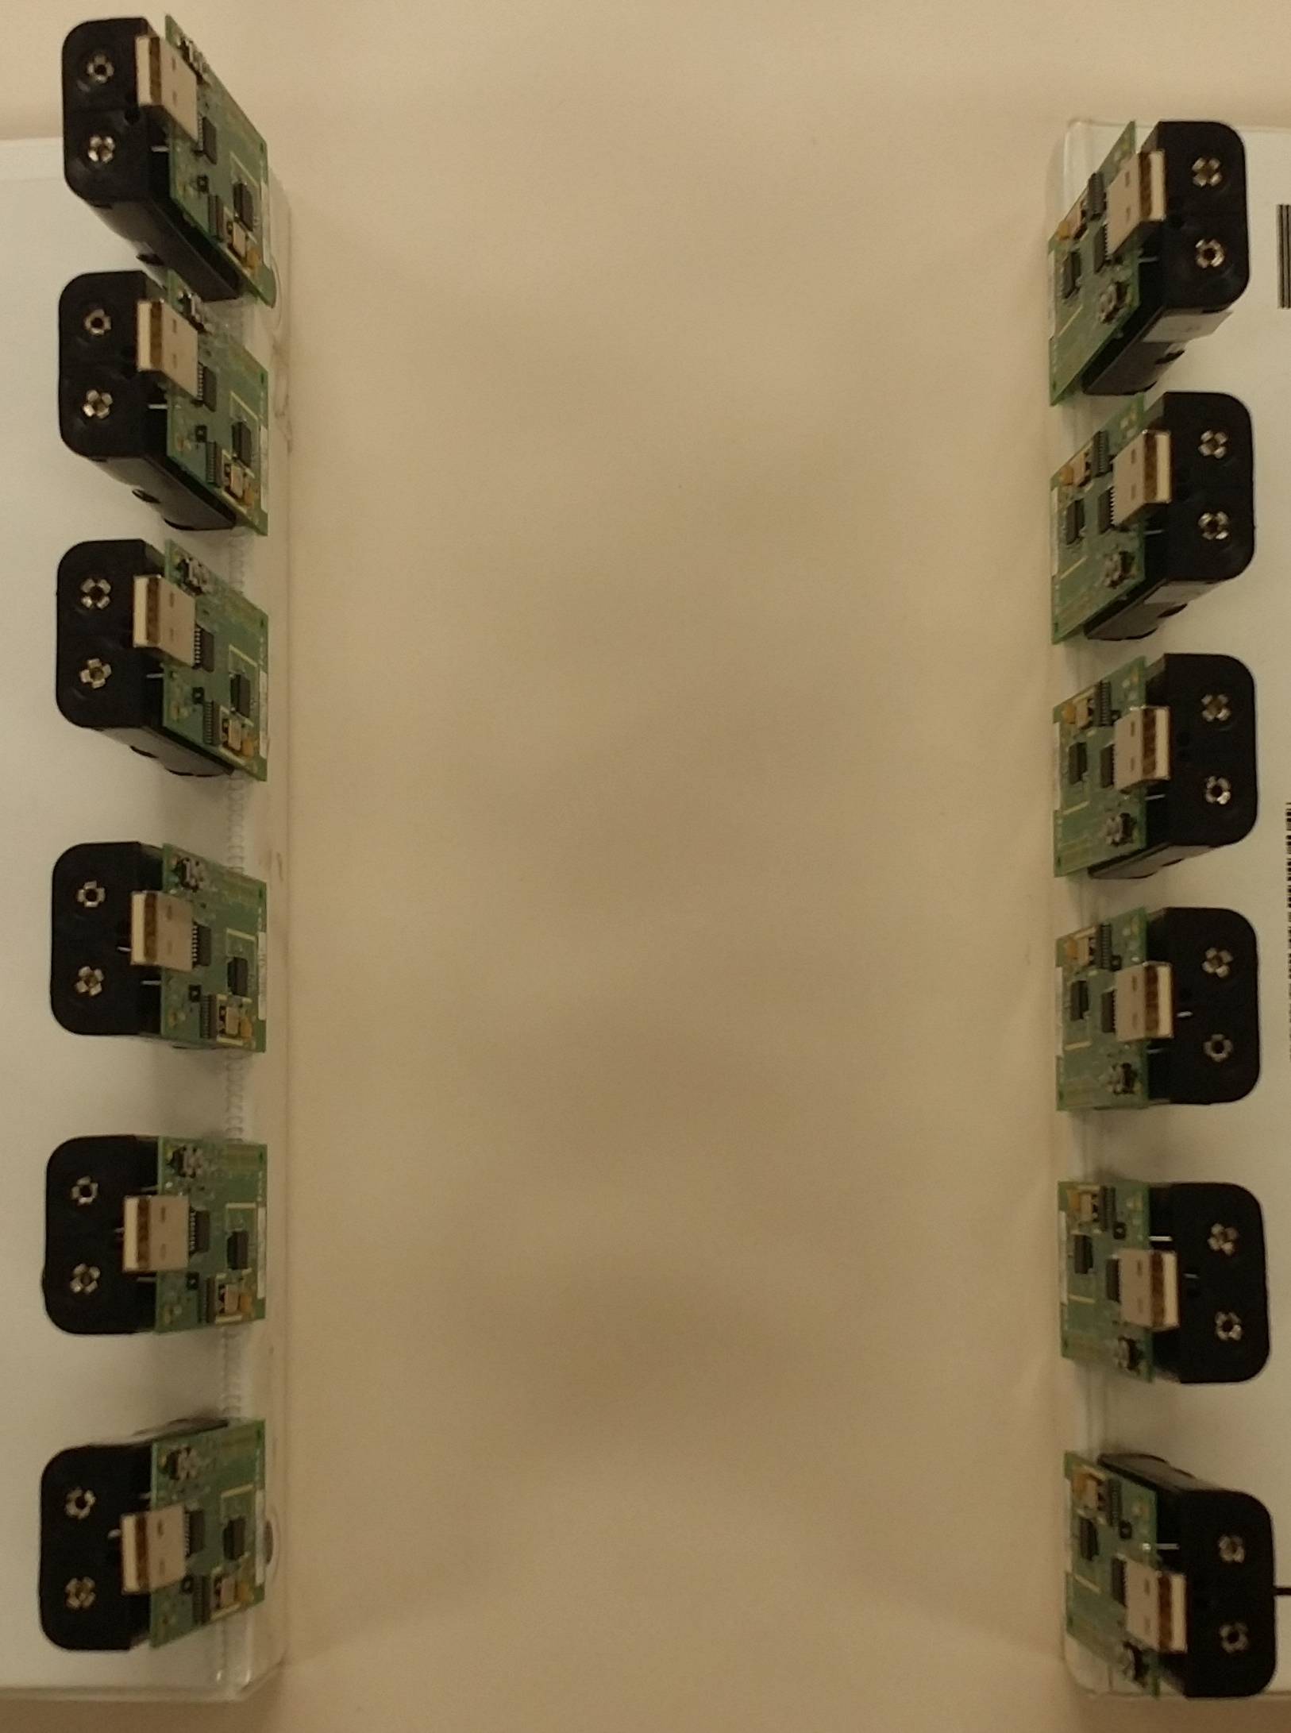  
 **Figure 2-6 Sensor Mote**

The matrix size in the output file will depend on the size of the Wireless Sensor Network as well. For example, if we set the Wireless Sensor Network as 12*12, then the matrix in the output file will be this pattern:

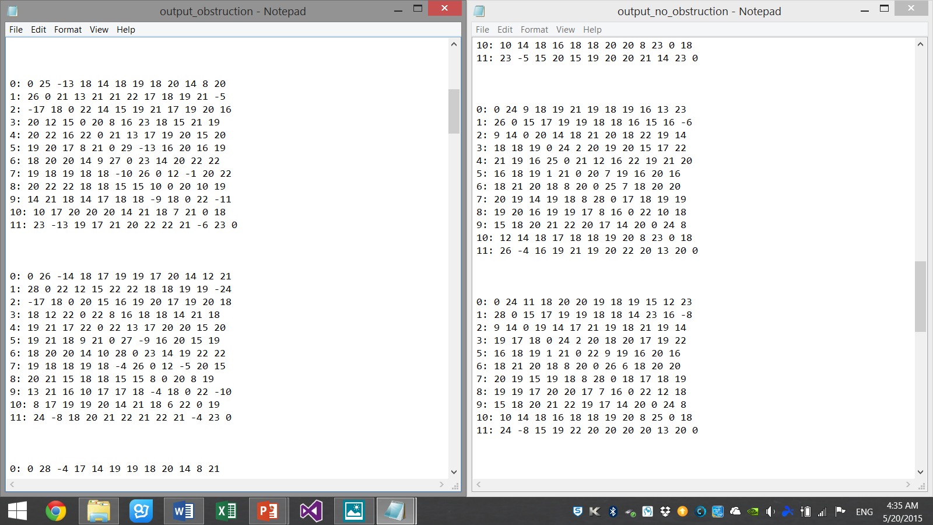

**Figure 2-7 Output sample**

* + - 1. **2*2 Wireless Sensor Network**In 2*2 Wireless Sensor Network, 2 TelosB Motes will be used as sensors in the network, and 1 TelosB mote will be used as Base Station. In total, there will be 3 TelosB motes in 2*2 Wireless Sensor Network.  
           
         The size of the output matrix will be 2*2.  
          **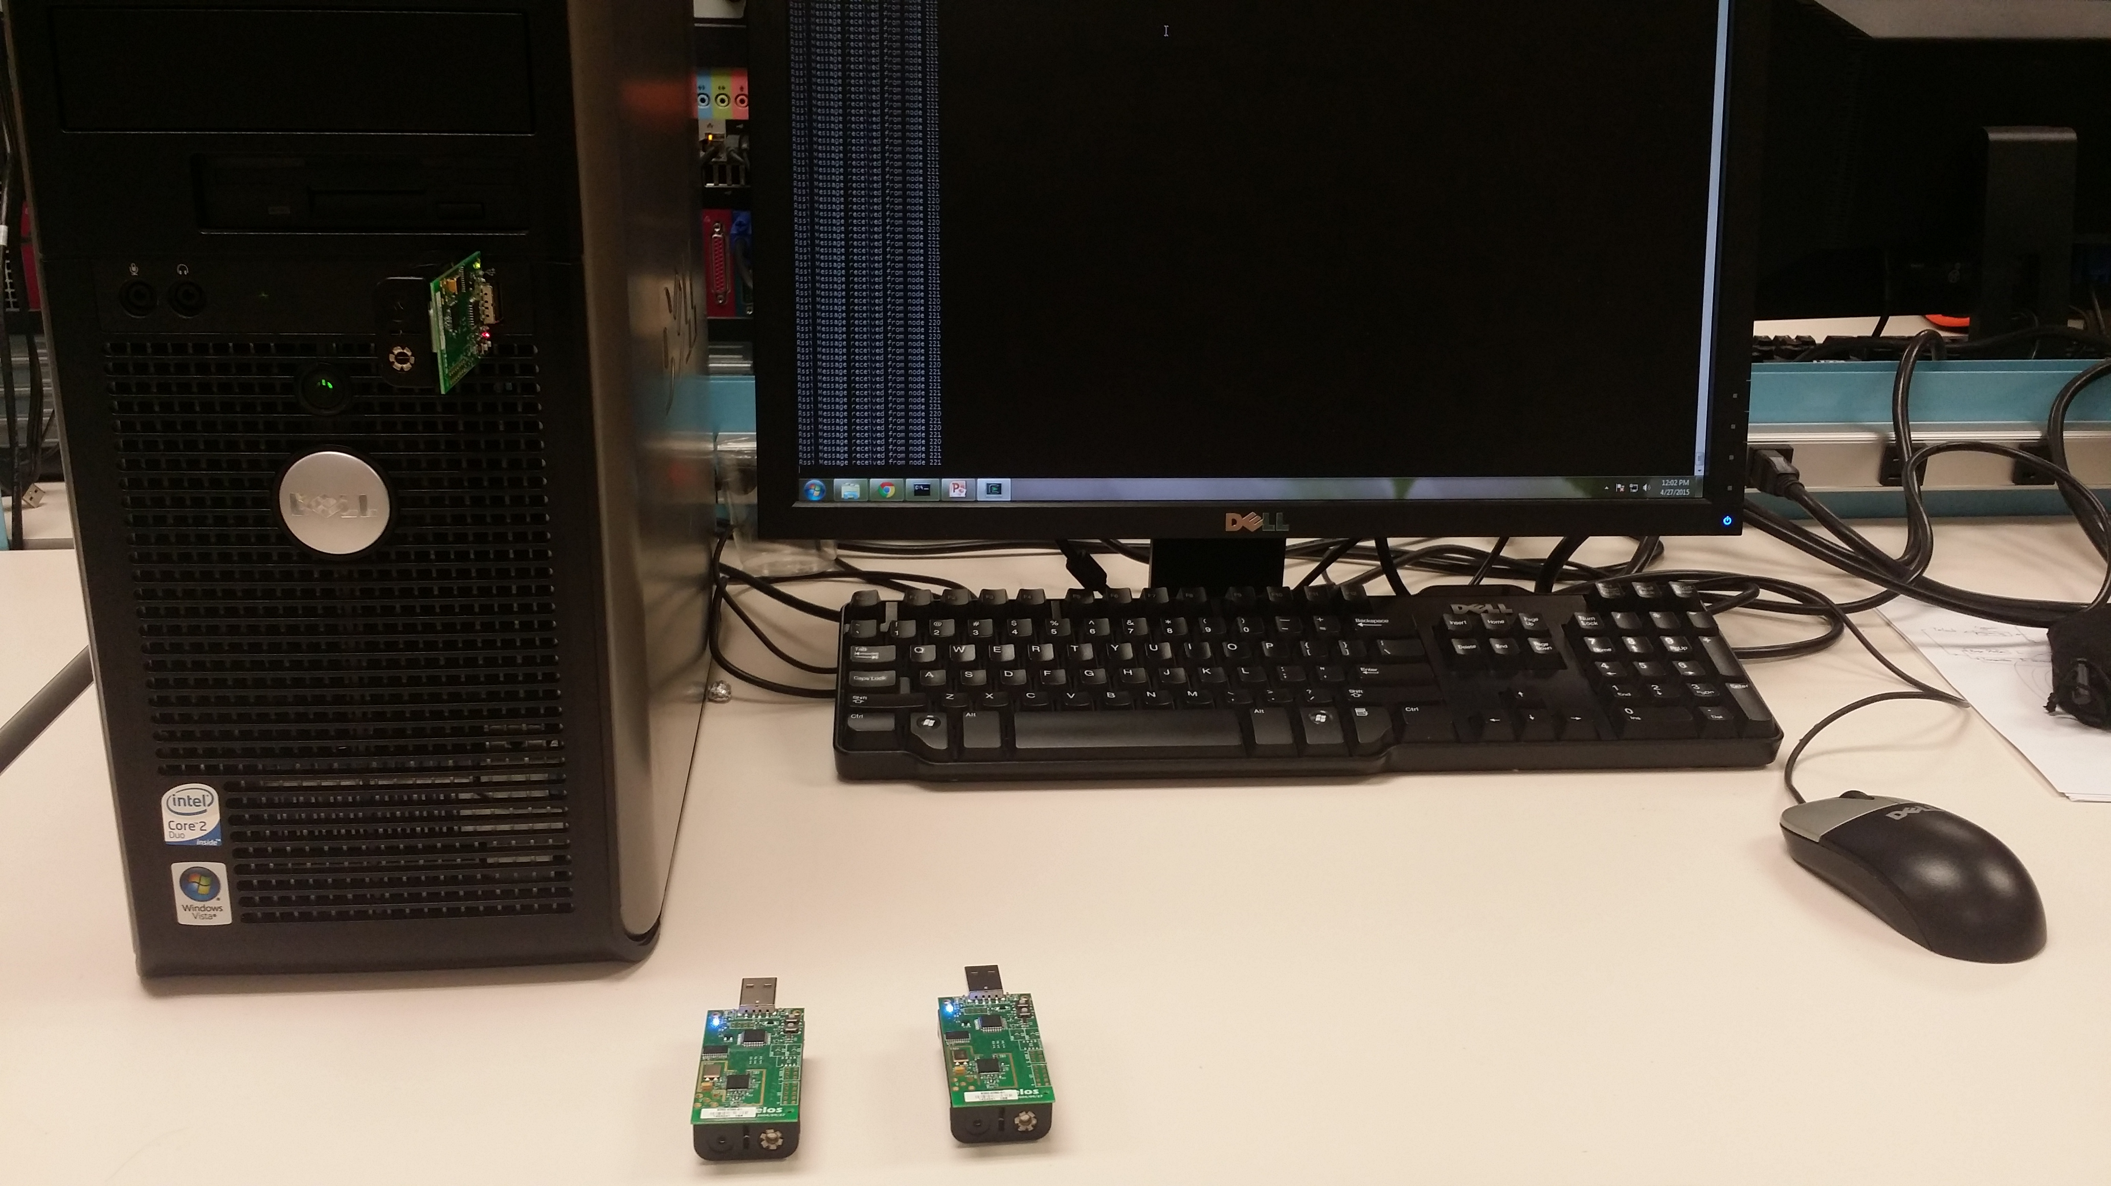  
          Figure 2-8 2*2 Wireless Sensor Network**
      2. **3*3 Wireless Sensor Network**In 3*3 Wireless Sensor Network, 3 TelosB Motes will be used as sensors in the network, and 1 TelosB mote will be used as Base Station. In total, there will be 4 TelosB motes in 3*3 Wireless Sensor Network.  
           
         The size of the output matrix will be 3*3.  
           
         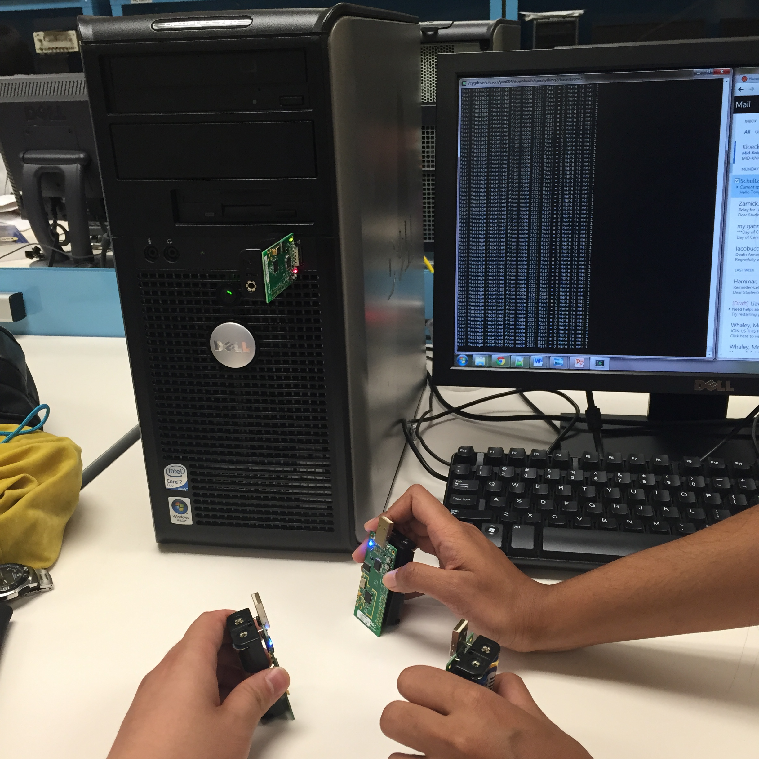  
          **Figure 2-9 3*3 Wireless Sensor Network**
      3. **4*4 Wireless Sensor Network**In 4*4 Wireless Sensor Network, 4 TelosB Motes will be used as sensors in the network, and 1 TelosB mote will be used as Base Station. In total, there will be 5 TelosB motes in 4*4 Wireless Sensor Network.  
           
         The size of the output matrix will be 4*4.  
           
         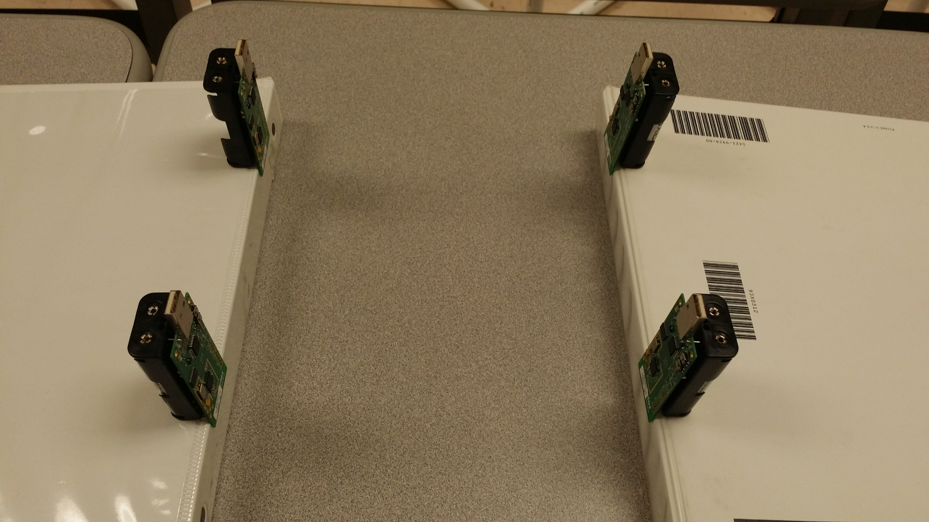 **Figure 2-10 4*4 Wireless Sensor Network**
      4. **12*12 Wireless Sensor Network**In 12*12 Wireless Sensor Network, 12 TelosB Motes will be used as sensors in the network, and 1 TelosB mote will be used as Base Station. In total, there will be 13 TelosB motes in 12*12 Wireless Sensor Network.  
           
         The size of the output matrix will be 12*12.

** Figure 2-11 12*12 Wireless Sensor Network**

* + 1. **Working Concept for the Wireless Sensor Network**At one time, there will be only one TelosB Mote in the Wireless Sensor Network acting as a transmitter; others will be acting as receivers. The Mote0 will be the transmitter first, then following by Mote1, Mote2 and so on.

**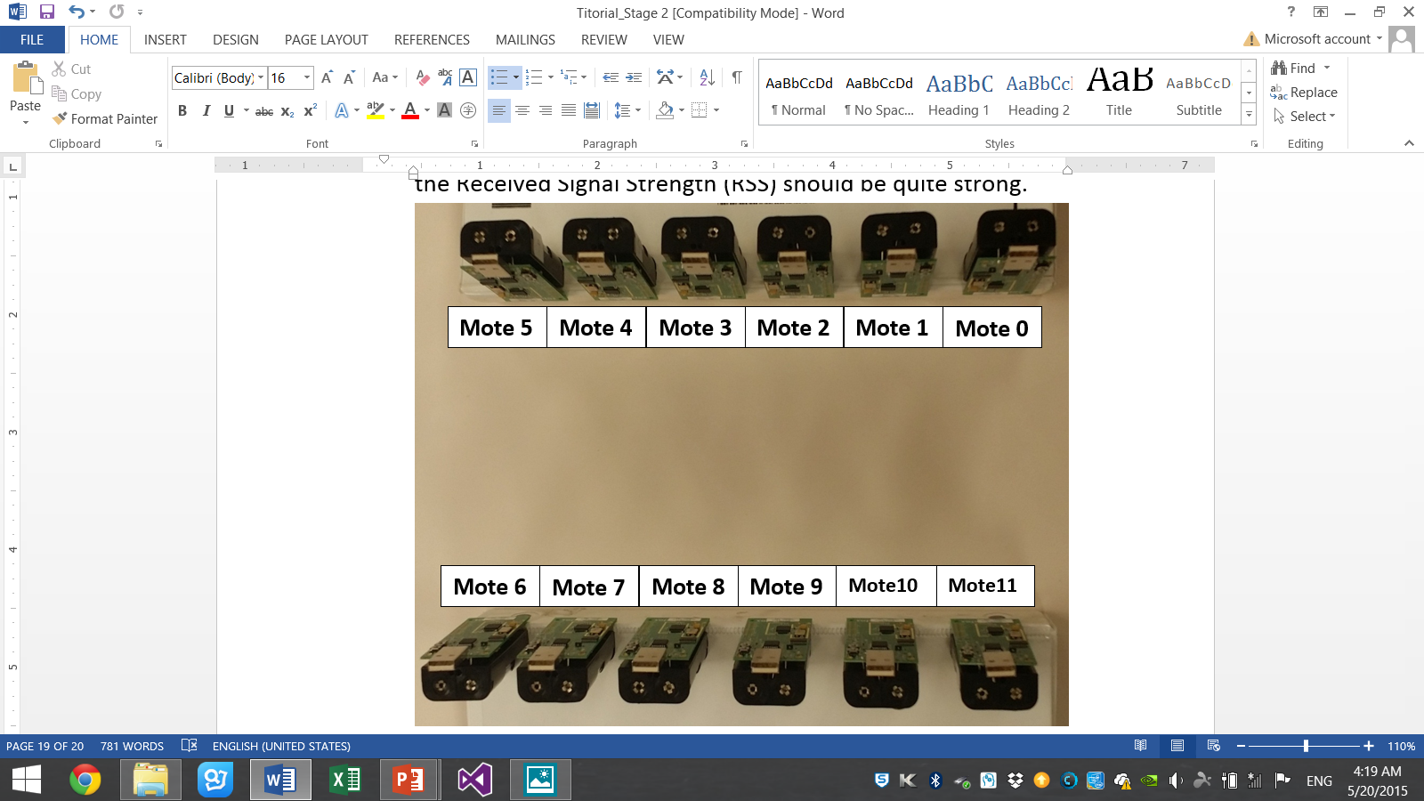  
 Figure 2-12 Wireless Sensor Network**

For example, in the 12 * 12 Wireless Sensor Network, Mote 0 will be the transmitter first, mote 1 to mote 11 will be receivers. After each of the receivers received the Received Signal Strength (RSS), then they will send back to Base Station Mote in sequence. Then after that, the Mote 1 will be the transmitter, and mote 0, mote 2 to mote 11 will be the receivers to receive the RSS. Then mote 2 will act as transmitter, following by mote 3, mote 4 until mote 11. After mote 11 finished transmissions to others, and the Base Station Mote finished receiving all the data from the other motes in the Wireless Sensor Network. Then one completed matrix will be formed.

* + 1. **Reading the Result**The output matrix will be saved in a text file.

In the matrix, the Row number mans the mote number, which is acting as the transmitter. The Column number means the mote number, which is acting as the receiver. The data inside will be positive or negative or zero.  
  
Positive RSS value means the Received Signal Strength (RSS) is strong. Larger RSS value means the RSS is stronger.

Negative RSS value means the RSS is very weak.

Zero means invalid data, because one mote cannot act as a transmitter and a receiver at same time.

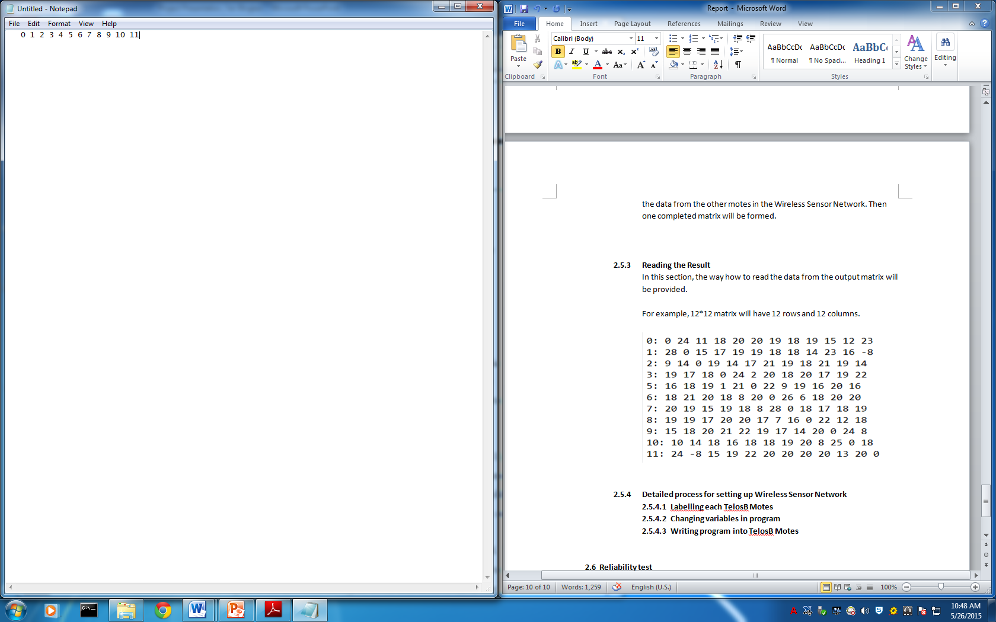  
  
 **Figure 2-13 Output File**For example, 12*12 matrix will have 12 rows and 12 columns. For example, the “23” is at the Row0 and Column12, so it means when mote 0 is the transmitter and mote 11 is the receiver, the Received Signal Strength (RSS) is “23”.

* + 1. **Detailed process for setting up Wireless Sensor Network  
       (For more detailed processes, please refer to Tutorial—Stage2)**
       1. **Labeling each TelosB Motes**Label the Base Station Mote as “B”; Label other sensor motes as “0”,”1”,”2”,”3”…  
            
            
           **Figure 2-14 Labeled TelosB Mote**
       2. **Changing variables in program**
          1. Open the spin.h file, which is located in this location: “C:\cygwin\spin”. (Open with Notepad++)  
             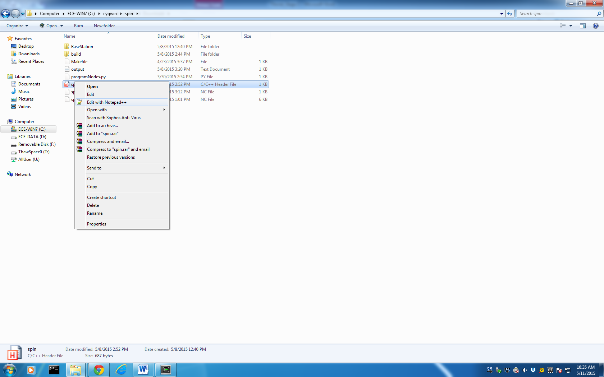  
              **Figure 2-14 Open spin.h File**

* + - * 1. Modify the value of NUM_NODES to the number of motes you will use in the network. (excluding the base-station mote)  
             
           Take 4 motes for an example:  
           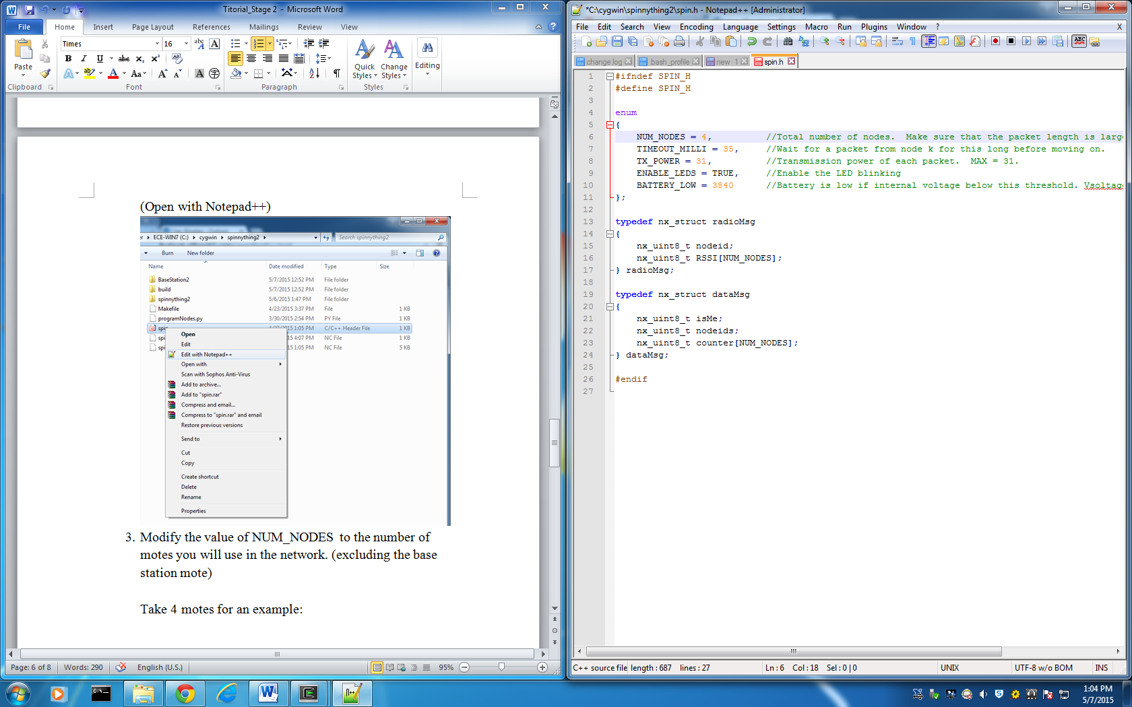  
            **Figure 2-15 Change NUM_NODES**
      1. **Writing program into Sensor TelosB Motes**
         1. Right click “Cygwin Terminal”, which is the icon like the following:  
             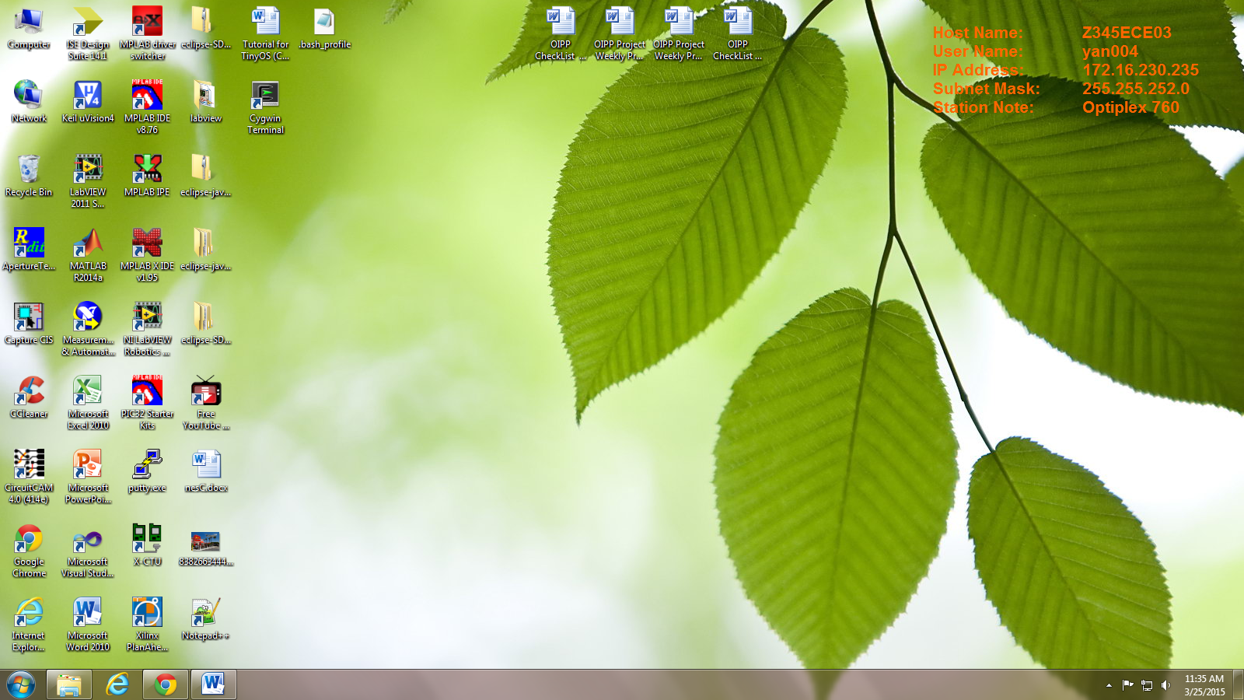

**Figure 2-16 Cygwin 1**

Run Cygwin as an administrator  
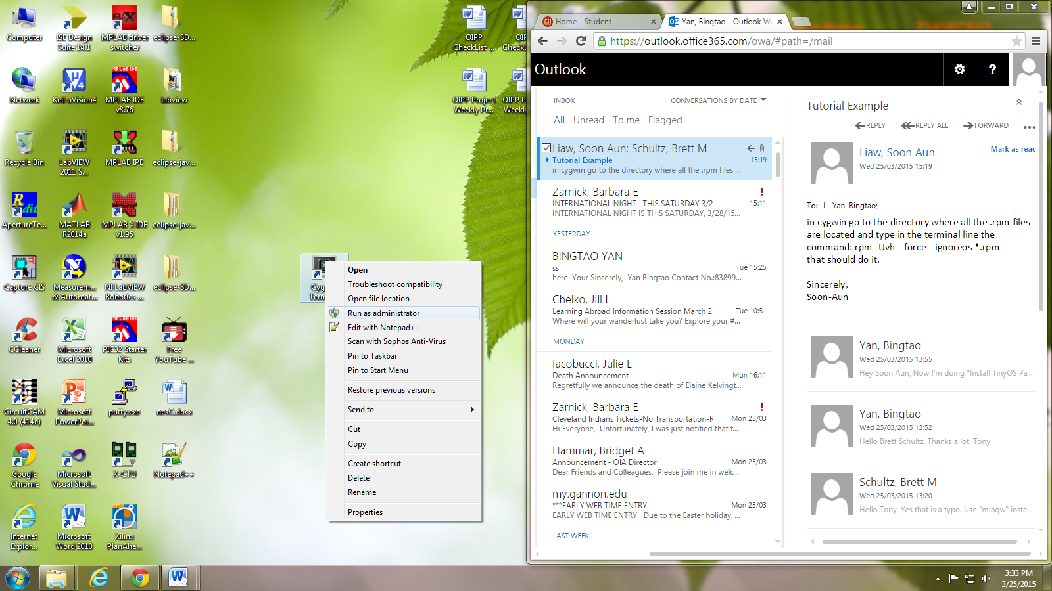  
 **Figure 2-17 Cygwin 2**

* + - * 1. Type “cd c:”, then press Enter key;

Type “ls”, then press Enter key:

You should be able to see “Cygwin” file inside the list.

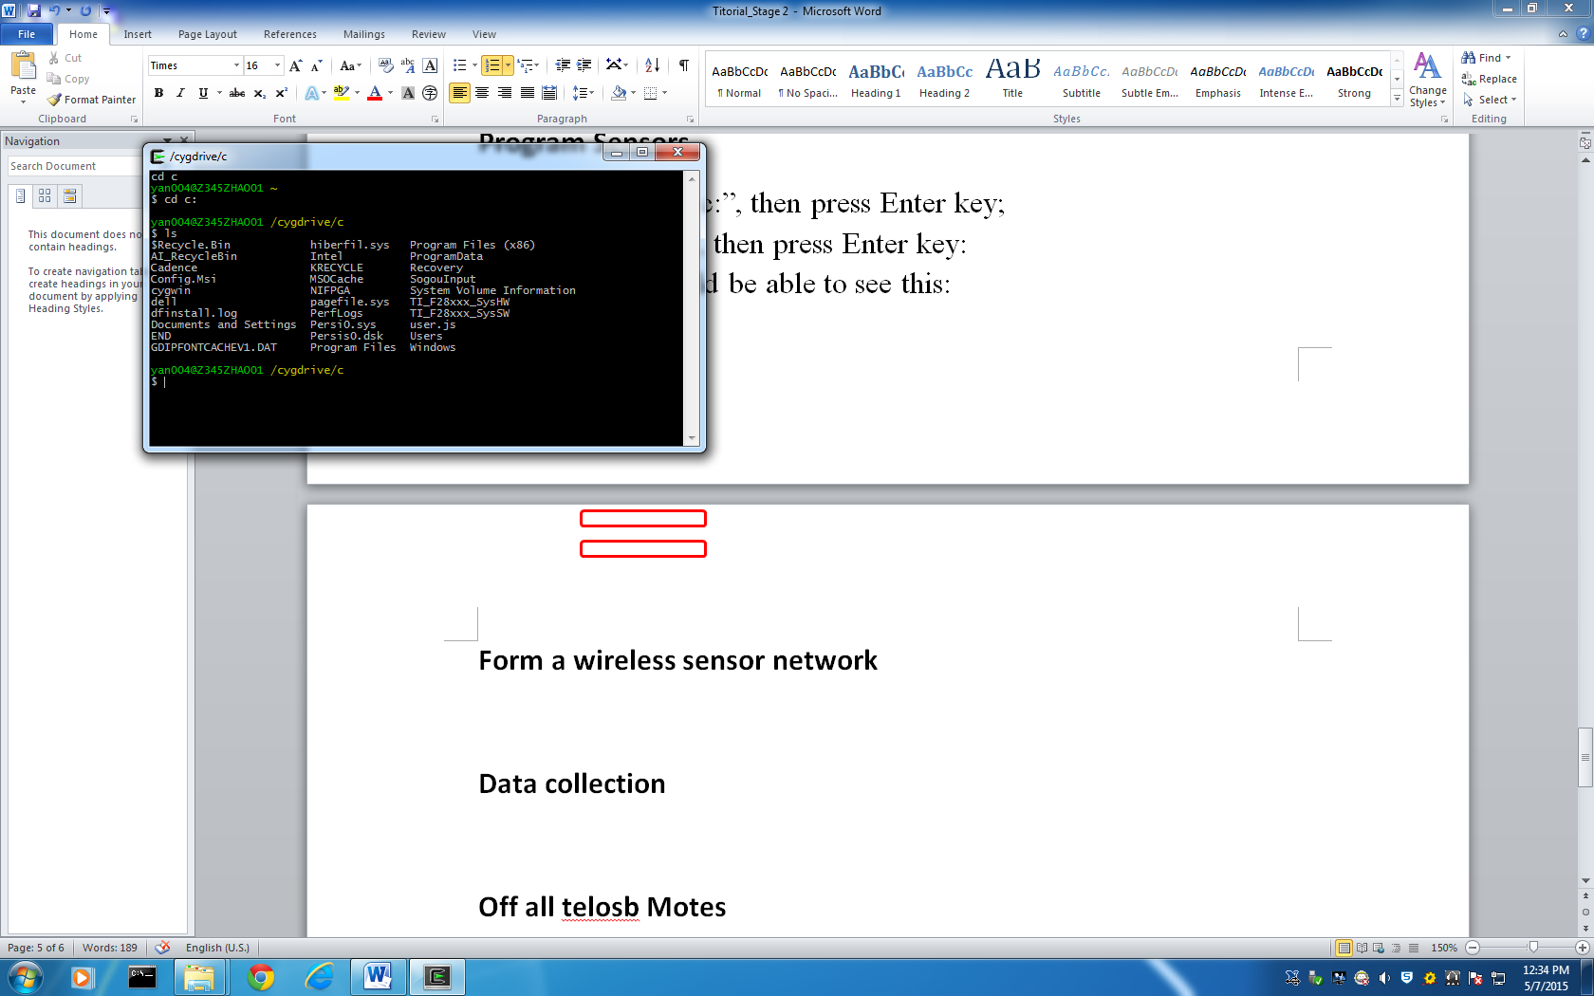 **Figure 2-18 Cygwin 3**

* + - * 1. Type “cd cygwin”, then press Enter key;

Type “ls”, then press Enter key:

You should be able to see “spin” file inside the list.  
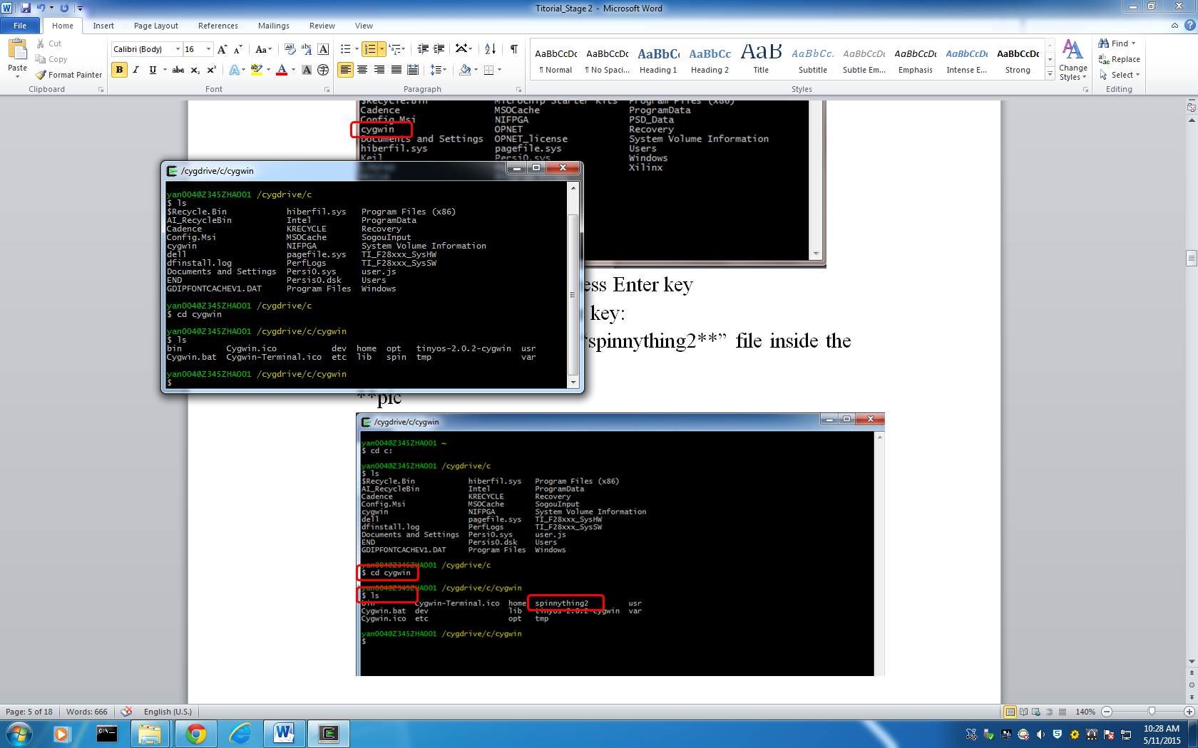 **Figure 2-19 Cygwin 4**

* + - * 1. Type “cd spin”, then press Enter key;

Type “ls”, then press Enter key:

You should be able to see “BaseStation” file inside the list.

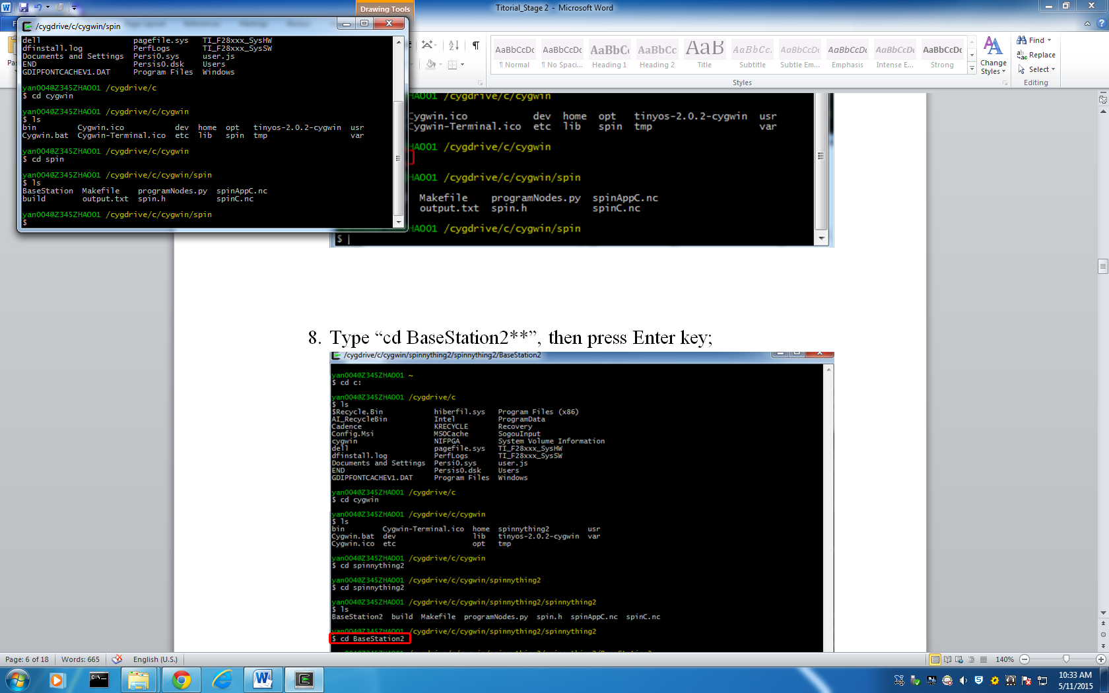 **Figure 2-20 Cygwin 5**

* + - * 1. Plug in one unused Telosb Mote, then type “motelist” inside Cygwin Terminal and press Enter Key.  
           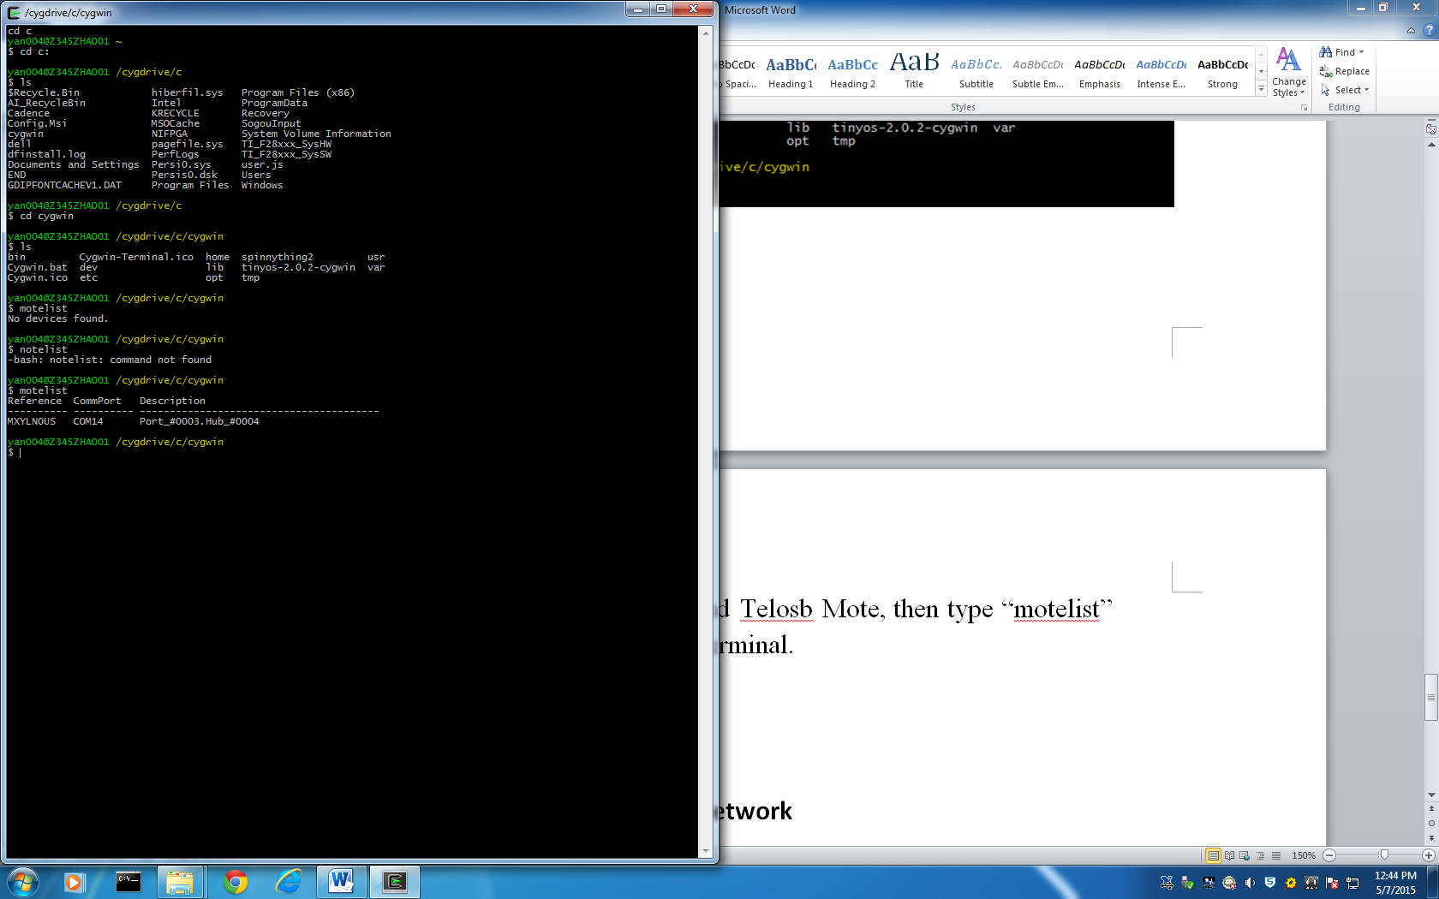 **Figure 2-21 Cygwin 6**
        2. Use command "make telosb install,n" where n is the mote ID ranging from 0 to [NUM_NODES - 1].

If you are using 4 motes plus 1 base-station mote, then you will install Mote ID 0 to 3.   
  
Take installing Mote ID 0 as an example:  
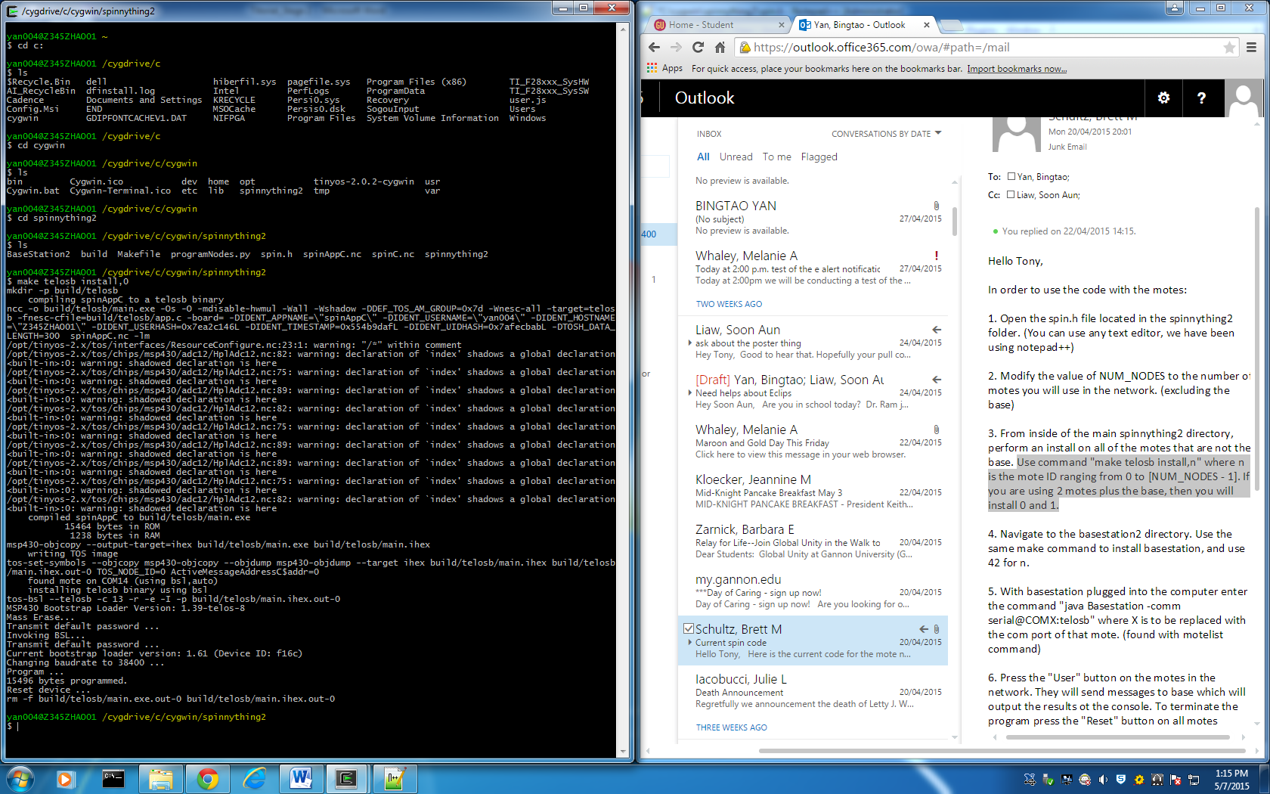 **Figure 2-22 Cygwin 7**

* + - * 1. This TelosB Mote should be able to run as a Base Station now.
      1. **Writing program into Base Station TelosB Motes**
         1. Run Cygwin as an administrator  
              
             **Figure 2-23 Cygwin 8**
         2. In Cygwin terminal, type “cd c:”, then press Enter key:  
            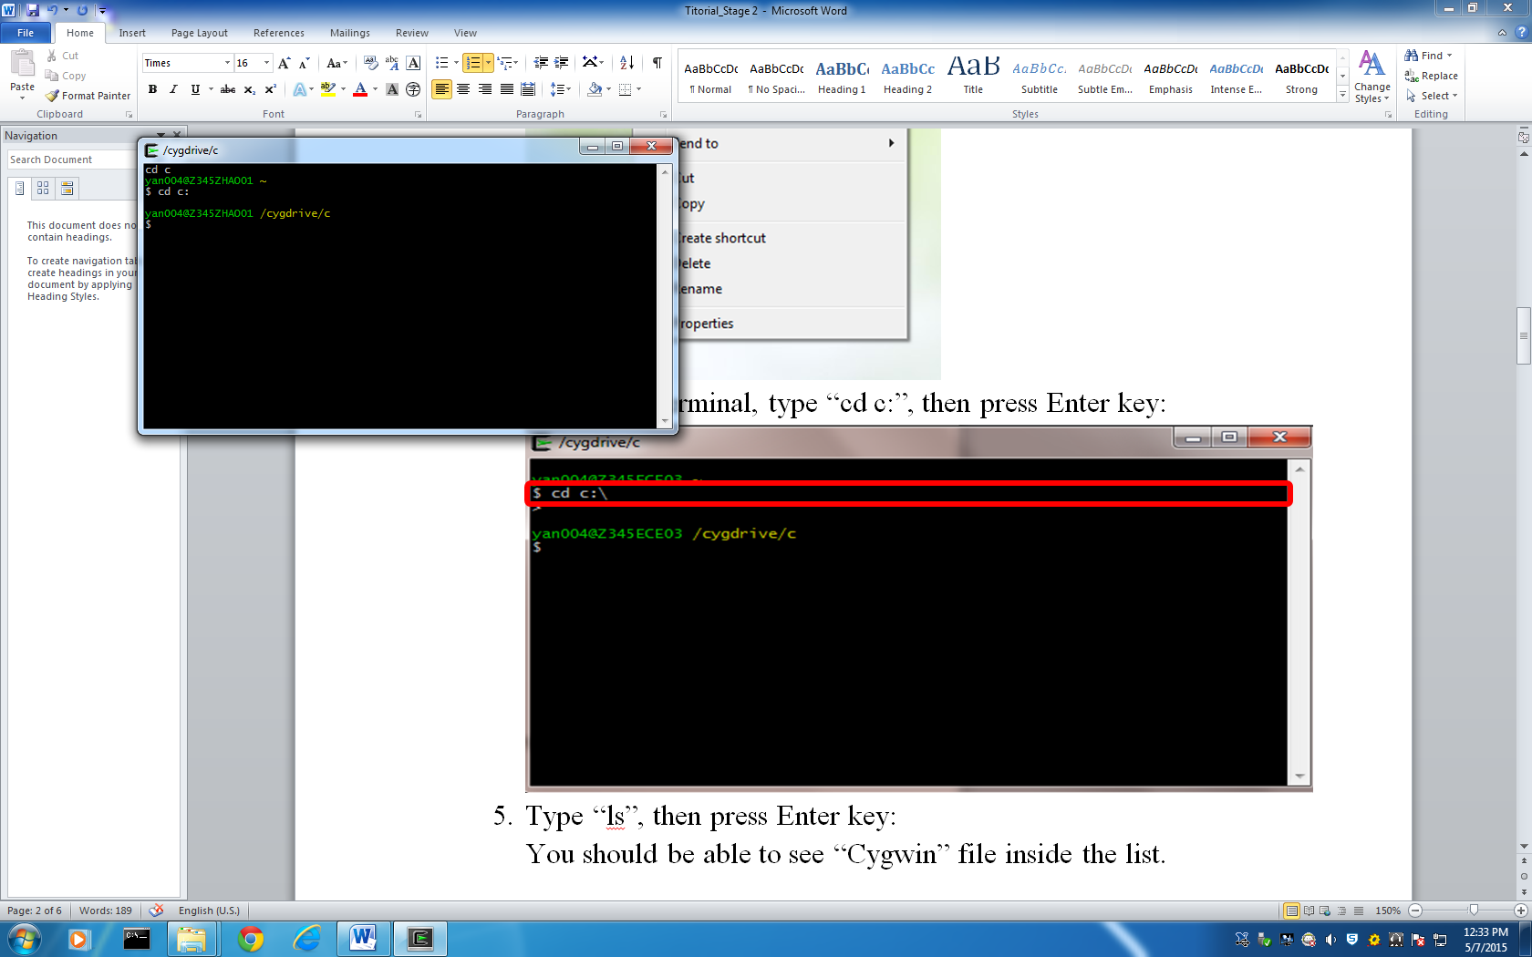 **Figure 2-24 Cygwin 9**
         3. Type “ls”, then press Enter key:

You should be able to see “Cygwin” file inside the list.  
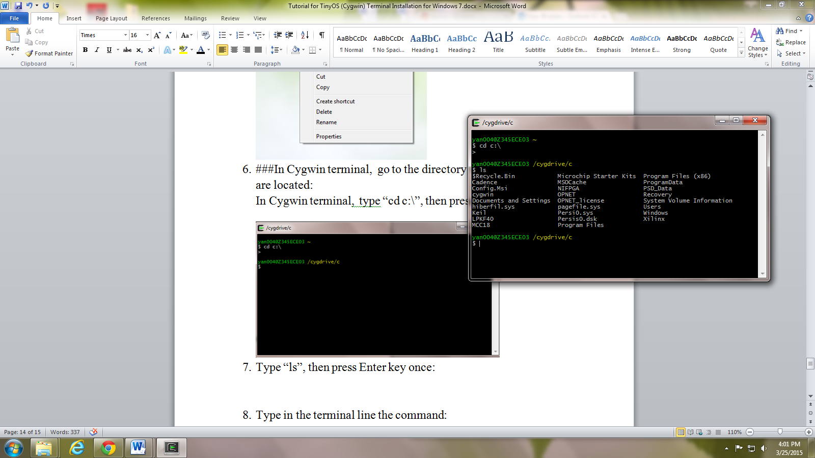 **Figure 2-25 Cygwin 10**

* + - * 1. Type “cd cygwin”, then press Enter key

Type “ls”, then press Enter key:  
You should be able to see “spin” file inside the list.  
 **Figure 2-26 Cygwin 11**

* + - * 1. Type “cd spin”, then press Enter key;

Type “ls”, then press Enter key:

You should be able to see “BaseStation” file inside the list.  
 **Figure 2-27 Cygwin 12**

* + - * 1. Type “cd BaseStation”, then press Enter key;  
           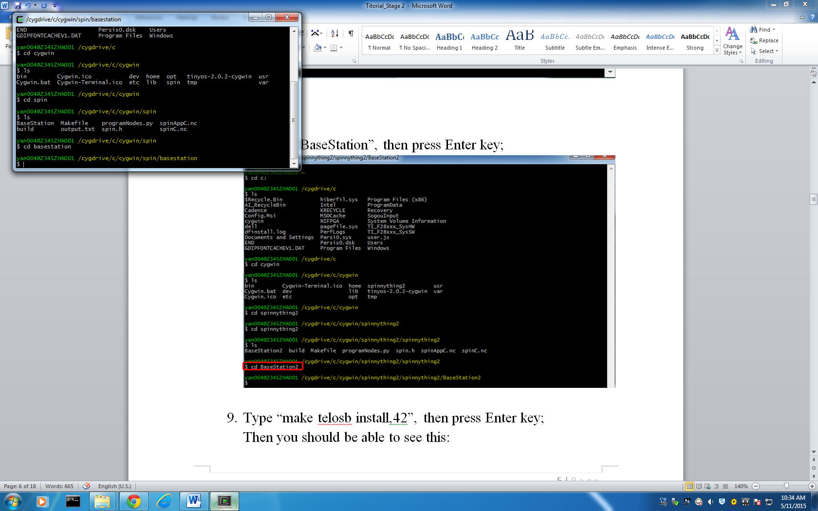 **Figure 2-28 Cygwin 13**
        2. 9. Type “make telosb install,42”, then press Enter key;  
           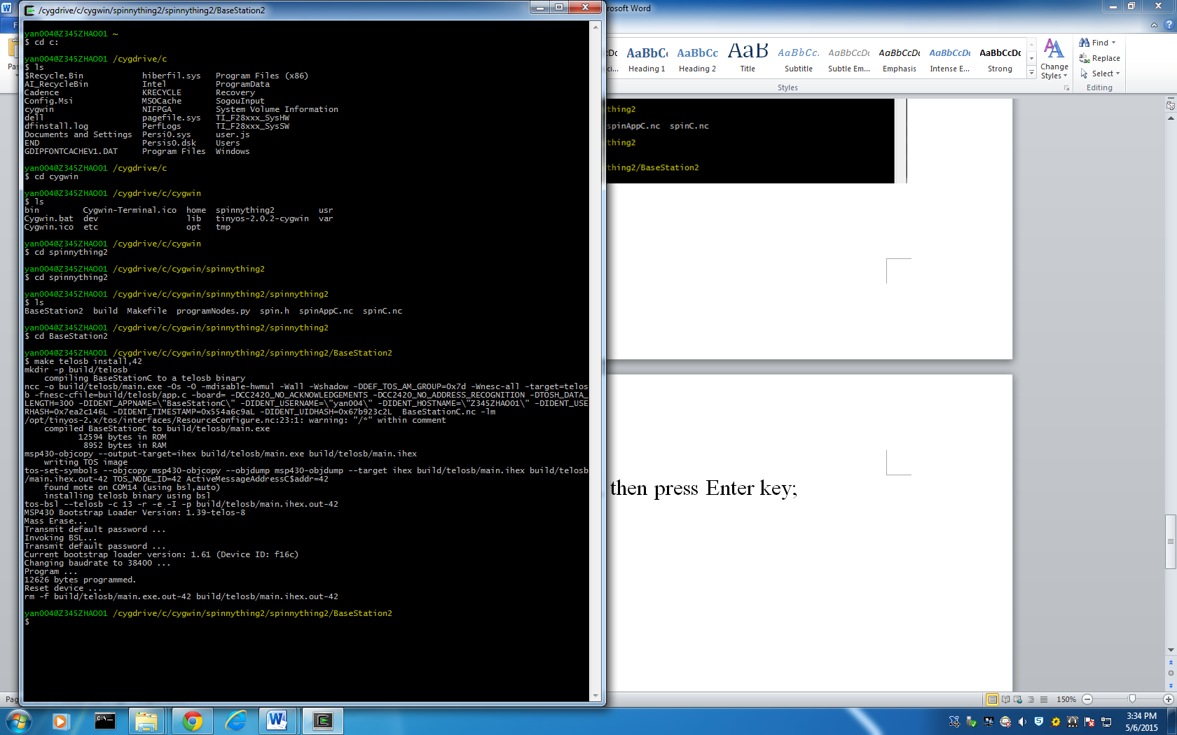 **Figure 2-29 Cygwin 14**
        3. “BaseStation” program should be able to run now.

* 1. **Reliability test**

It’s important to do a reliability test. After the test, we will know the success rate and possible errors. So in future development, the developer can improve based on this result.

During the test, the whole system run for 5 minutes. There are 1837 matrixes in the output file. We analyzed from this output.

* + 1. **Success rate**There are 1837 matrixes in the output file.   
       However, 1405 of them are correct.   
       Therefore, the success rate is (1405/1837)*100%=76.28%.
    2. **Possible errors** 
       1. **Miss the beginning part**

**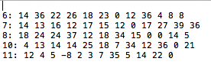  
 Figure 2-30 Reliability Test 1**

This error always happened on the first matrix. It is very obvious, because there are several rows of data lost when this error happened.

* + - 1. **Miss one row of data  
         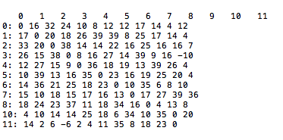 Figure 2-31 Reliability Test 2**

This error always happened randomly. It’s not very easy to find this error, because there is only one row of data lost. In the example, row number “9” is missing.

1. **Conclusion and future work**

In conclusion, stage 1 (Data Collection Stage) has been completed. Now, we are able to get the real-time data from the environment. As a result, stage 2 (Information Display Stage) is able to plot the outline of the object based on data from stage 1.

Moreover, tutorials, including detailed processes, are completed as well, so that future users will be able to set all the devices and run the whole system based on these tutorials.  
  
In the future, developers could focus on stage 2 to do the information display, so that users will be able to see the object and its position visually through the computer. Moreover, so far, we only did the indoor testing. In the future, developers also could do the outside environment testing to see the reliability.

**Reference:**

[1] Crossbow Company, TelosB_Datasheet [Online]. Available: <http://www.willow.co.uk/TelosB_Datasheet.pdf>

[2] TinyOS[online]. Available: <http://www.tinyos.net/>

[3] Java [online]. Available: <https://www.java.com/en/download/faq/whatis_java.xml>

[4] Cygwin[online]. Available: <https://www.cygwin.com/>